**JAISHREE 231901011**

**EXERCISE 1B WINDOWS FUNDAMENTALS 2**

**AIM**:

To explore advanced Windows functionalities, including System Configuration, User Account Control (UAC) settings, Resource Monitoring, and the Windows Registry, to enhance system management and troubleshooting skills.

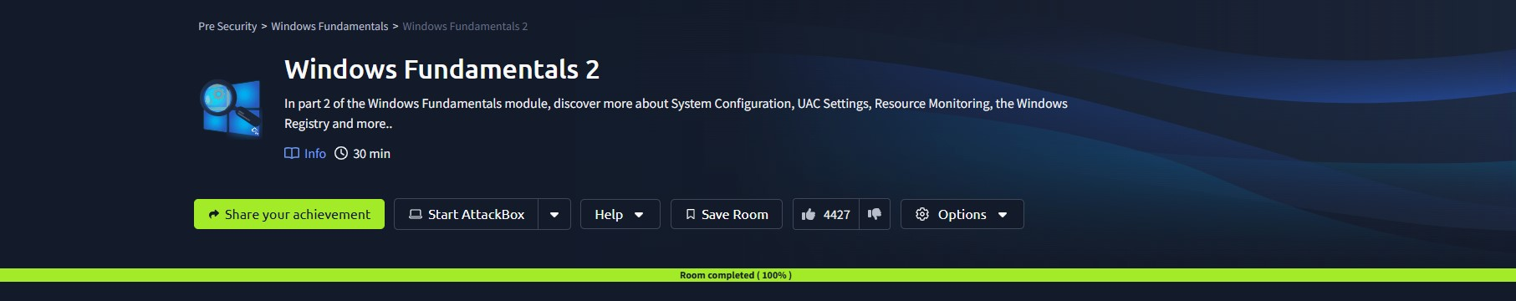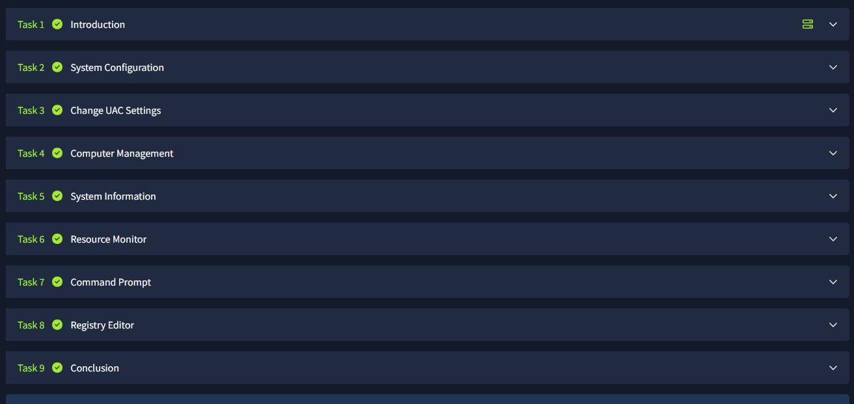

**RESULT**:

Successfully gained knowledge of System Configuration, adjusted UAC settings, monitored system resources, and understood the structure and importance of the Windows Registry.